Hierarchical clustering: same as K-means but different process

* Agglomerative: bottom-up approach
* Divisive: reverse of agglomerative

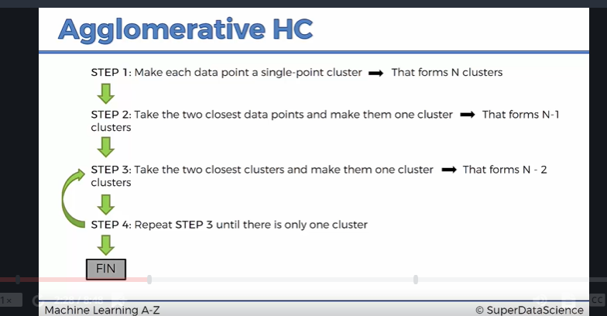

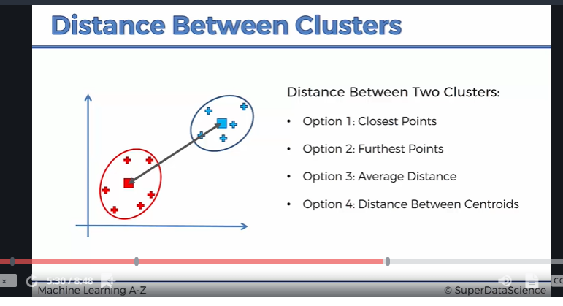

Dendograms: it is like the memory of HC algorithm. The height of the bar represents the Euclidean distance between the cluster (a.k.a the dissimilarity between the cluster)

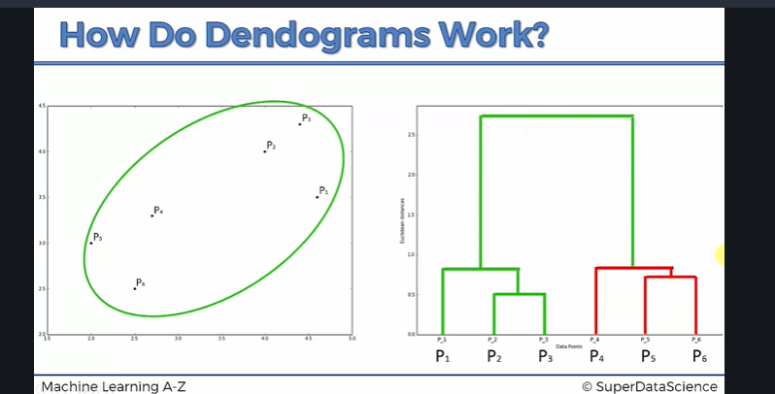

After dendograms is constructed, we can set a dissimilarity threshold, to remove any cluster that is above the threshold

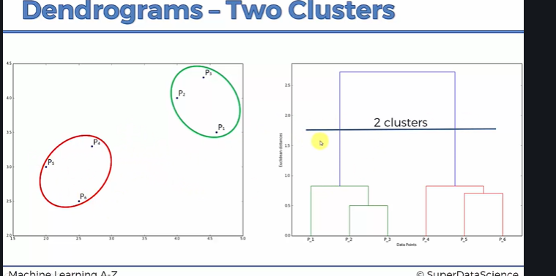

How to select the perfect threshold?

* Find the longest vertical line that doesn’t cross with any horizontal lines, and set a threshold that crosses the longest vertical line.